Made in America Lifetime Guarantee
Thank you for purchasing this instrument from Intellitronix. We value our customers!

INSTALLATION GUIDE
Boost Pressure Sender
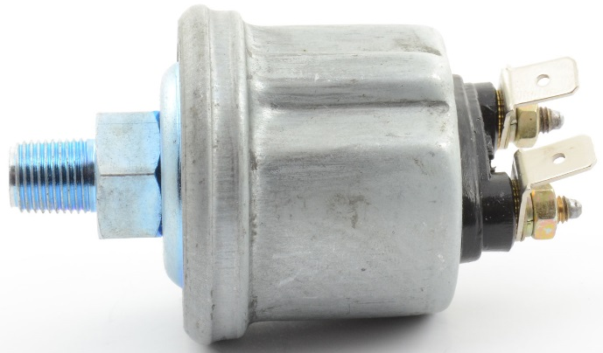
Part Number: S9019

Sender Wiring Instructions

Connect the tan wire directly to the terminal marked WK. The other terminal (G) should be connected directly to the engine ground.

Made in America Lifetime Guarantee

Technical Support

Monday – Friday
9am to 5 pm EST
(440) 359 7200
support@intellitronix.com

CHECK OUT THE SUPPORT PAGE AT
www.intellitronix.com

FOR QUICK ANSWERS (Q&A) TO YOUR QUESTIONS

This product carries a limited Lifetime Warranty.
This warranty is limited to replacement or repair of the unit at the discretion of Intellitronix.

RETURN POLICY PROCEDURES

Return Policy Instructions

- Download the Intellitronix Return/Repair Form and fill in the information on the form about the product.

- Place the product being returned in the original packaging that it came in and include a copy of the completed Intellitronix Return/Repair Form.

- All packages must be accompanied with an RMA Number.

Please call Technical Support at +1 440-359-7200 to receive an RMA Number.

- ​Mail the product being returned with the completed Return/Repair Form and a copy of the original sales invoice.
​
​Request for Product Refund
​
- ​All returns for a refund must have a completed Intellitronix Return/Repair Form included in the package with the returned product.

- If the return is for a product that is not defective a 20% restocking fee will be charged. The product must be in the same pristine condition that it was sent to you.

- Proof of purchase is required. Please include a copy of the original sales order with the returned product.

- All product must be returned undamaged and in working order in the original packaging including plexiglass, sending units, mounting hardware, or you will be subject to additional charges for product and accessories not returned.

- All refunds will be reviewed by the Accounting Office.

